# VRM UD SERVER-SIDE DATA ACCESS COMPONENT DEPLOYMENT AND CONFIGURATION

VRM UD SERVER-SIDE DATA ACCESS COMPONENT DEPLOYMENT AND CONFIGURATION 1

1. Retrieve the source code for Data Access Component (DAC) from source control 1

2. Deploy the DAC to the chosen server using either file copy approach or a setup process (not included) 1

Copy source code to the server 2

Configure application with IIS 3

Configure DAC by adding/modifying entries in Web.config file 4

## Retrieve the source code for Data Access Component (DAC) from source control

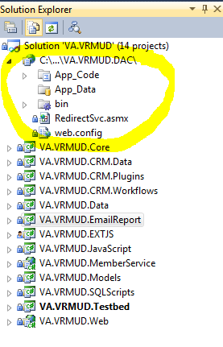

## Deploy the DAC to the chosen server using either file copy approach or a setup process (not included)

Please note that the server the DAC will be installed on should comply with following requirements:

* Must be able to be reached from PCR client workstations
* Must be able to reach all Web Service end-points (for Vetsnet Share and MAP-D services, Appeals, Pathways and others) through established security mechanism
* Must be able to reach CRM through the use of CRM server-side SDK

### Copy source code to the server

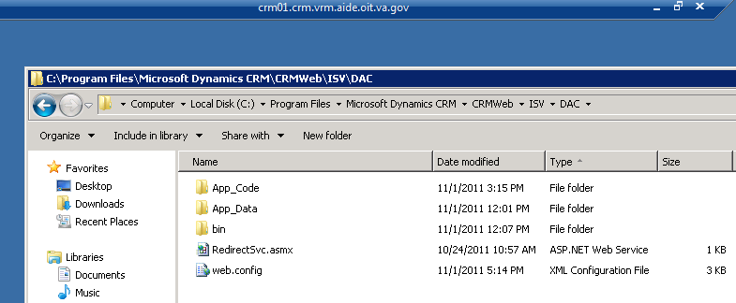

### Configure application with IIS

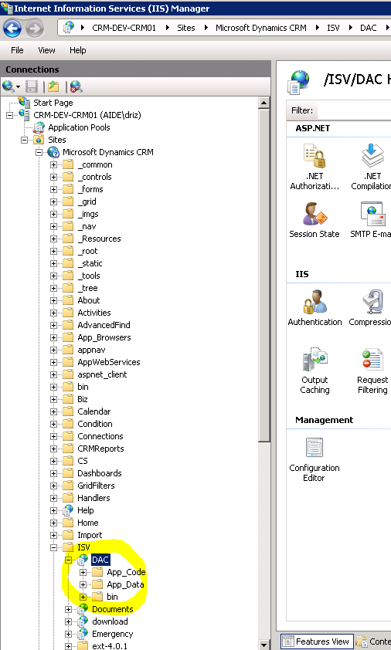

Note: make sure that DAC is configured to :

* Run under .NET 4.0 application pool
* Require Windows authentication

### Configure DAC by adding/modifying entries in Web.config file

#### Uri identifying target CRM server

<add key="CrmServer" value="http://10.153.50.201"/>

#### Organization name on CRM server

<add key="CrmOrgUniqueName" value="VRM"/>

#### Validation flag (1 or 0).

If Validation flag is 0, DAC will not require additional validation and will execute WS request on behalf of the user, relying on Windows authentication.

If Validation flag is 1, DAC will verify in addition that the calling user does exist as active (non-disabled) user in the specified CRM Organization.

<add key="ValidateUser" value="1"/>

#### Validation store.

If Validation flag is 1, and validation is required, and AllowedUsers key is missing or blank, DAC will query CRM to make sure that calling user does exist as active (non-disabled) user in the specified CRM Organization. If AllowedUsers is not blank, calling user will be validated against the list of names provided in AllowedUsers key.

<add key="AllowedUsers" value="AIDE\RKOLM;CRM\CRMTEST02;CRM\CRMTEST03;AIDE\CPOWELL;AIDE\RKUEHN;AIDE\SGOLDFEDDER "/>